1. The Overview

This website was built to contain all the documentation necessary to cover all the modules and suites contained in Operate Edge’s current offerings. The following page is to cover all the pages and describe which pages are complete and which ones are not. This will help in further documentation of the code in case of additional modules or deletion of any modules that were not found in the current offerings.

1. Index(home).html – completed
2. Delivery Management – main page completed but requires overview demo + main picture
   1. App Development Hub
      1. Sample structure in place, but needs main picture, proper accordion titles, accordion subheadings, accordion content
   2. Business Metrics Insights
      1. Sample structure in place, but needs main picture, proper accordion titles, accordion subheadings, accordion content
   3. Capacity Management Hub
      1. Sample structure in place, but needs main picture, proper accordion titles, accordion subheadings, accordion content
   4. Knowledge Center
      1. Sample structure in place, but needs main picture, proper accordion titles, accordion subheadings, accordion content
   5. Learn Center
      1. Sample structure in place, but needs main picture, proper accordion titles, accordion subheadings, accordion content
   6. Release Management
      1. Sample structure in place, but needs main picture, proper accordion titles, accordion subheadings, accordion content
   7. Risk Management
      1. Sample structure in place, but needs main picture, proper accordion titles, accordion subheadings, accordion content
   8. Transition Management
      1. Sample structure in place, but needs main picture, proper accordion titles, accordion subheadings, accordion content
3. System Management
   1. Batch Operations Management
      1. Sample structure in place, but needs main picture, proper accordion titles, accordion subheadings, accordion content
   2. Data Operations Management
      1. Sample structure in place, but needs main picture, proper accordion titles, accordion subheadings, accordion content
   3. Infrastructure Hub
      1. Sample structure in place, but needs main picture, proper accordion titles, accordion subheadings, accordion content
   4. Licenses and Certifications
      1. Sample structure in place, but needs main picture, proper accordion titles, accordion subheadings, accordion content
   5. Logistics Analysis Hub
      1. Sample structure in place, but needs main picture, proper accordion titles, accordion subheadings, accordion content
   6. Web Analysis Hub
      1. Sample structure in place, but needs main picture, proper accordion titles, accordion subheadings, accordion content
4. Service Management
   * 1. Sample structure in place, but needs main picture, proper accordion titles, accordion subheadings, accordion content
5. Project Management
   1. Artifact Search
      1. Structure, main picture, proper accordion titles, accordion subheadings, but missing pictures and demos in accordion content
   2. Contracts
      1. Structure, main picture, proper accordion titles, accordion subheadings, pictures included, but missing demos in accordion content
   3. Dashboard
      1. Fully completed
   4. Initiatives
      1. Structure, main picture, proper accordion titles, accordion subheadings, but missing pictures and demos in accordion content
   5. Purchase Order
      1. Structure, main picture, proper accordion titles, accordion subheadings, pictures included, but missing demos in accordion content
   6. Reports
      1. Structure, main picture, proper accordion titles, accordion subheadings, but missing pictures and demos in accordion content
6. Code Portions
   1. Make an accordion

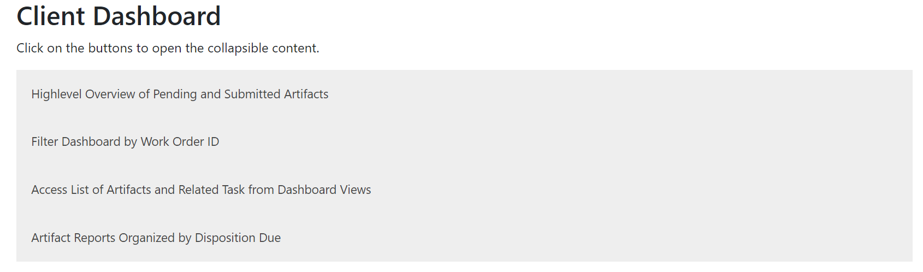

To create a base structure with only two panels like above, copy the code below:

<div class="float-container col-sm-6 col-lg-12 space">

<button class="accordion">Insert Title</button>

    <div class="panel">

        <div>

          <div class="space">

            <h6>Steps</h6>

            <p>Write steps of what is necessary to get to this view </p>

            <img src ="../Images/WRITE IMAGE NAME HERE" width="80%" >

          </div>

          <div class="space">

            <h6>Demo</h6>

            <video width="320" height="240" class="center" controls>

              <source src="../Images/USI-KT Recordings Day2.mp4" type="video/mp4" class="center">

              Your browser does not support the video tag.

            </video>

          </div>

        </div>

      </div>

button class="accordion">Insert Title</button>

    <div class="panel">

        <div>

          <div class="space">

            <h6>Steps</h6>

            <p>Write steps of what is necessary to get to this view </p>

            <img src ="../Images/WRITE YOUR IMAGE NAME HERE" width="80%" >

          </div>

          <div class="space">

            <h6>Demo</h6>

            <video width="320" height="240" class="center" controls>

              <source src="../Images/ WRITE YOUR VIDEO NAME HERE" type="video/mp4" class="center">

              Your browser does not support the video tag.

            </video>

          </div>

        </div>

      </div>

</div>

(1) The <div class="float-container col-sm-6 col-lg-12 space">

(1) The first div tab containing the class “float-container” is used to bunch all of the panels together. This will be the starting point of your accordian.

(2) The button html heading allows you to have a tile for the panel, so the user knows what will be the contents that will be selected

(3) The panel tab sets up the panel so that you are able to click on the content and it will open and collapse depending on what the user selects

(4) Under the first space div html tag, there is a p tag that will enable you to write a short description regarding the specific content.

(5) Right below the p tag, there is an img src, this is where you will insert your picture from the images folder depending on how you saved it in the file. After taking a snapshot of your image, make sure to go in and save it with a unique title that you will remember in the images folder.

(6) In the demo section, there will be a source src tag, in this tag you will write the name of the file of the mp4 file in which you conducted the demo. After taking a snapshot of your video, make sure to go in and save it with a unique title that you will remember in the images folder.

* 1. Adding an additional topic panel



To create a single panel as seen above, insert the code below:

<button class="accordion">Insert Title</button>

    <div class="panel">

        <div>

          <div class="space">

            <h6>Steps</h6>

            <p>Write steps of what is necessary to get to this view </p>

            <img src ="../Images/WRITE YOUR IMAGE NAME HERE" width="80%" >

          </div>

          <div class="space">

            <h6>Demo</h6>

            <video width="320" height="240" class="center" controls>

              <source src="../Images/ WRITE YOUR VIDEO NAME HERE" type="video/mp4" class="center">

              Your browser does not support the video tag.

            </video>

          </div>

        </div>

      </div>

(1) The button html heading allows you to have a tile for the panel, so the user knows what will be the contents that will be selected

(2) The panel tab sets up the panel so that you are able to click on the content and it will open and collapse depending on what the user selects

(3) Under the first space div html tag, there is a p tag that will enable you to write a short description regarding the specific content.

(4) Right below the p tag, there is an img src, this is where you will insert your picture from the images folder depending on how you saved it in the file. After taking a snapshot of your image, make sure to go in and save it with a unique title that you will remember in the images folder.

(5) In the demo section, there will be a source src tag, in this tag you will write the name of the file of the mp4 file in which you conducted the demo. After taking a snapshot of your video, make sure to go in and save it with a unique title that you will remember in the images folder.

* 1. Adding an image

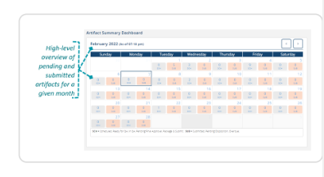

To add the image portion to your site, copy the code below:

            <img src ="../Images/WRITE IMAGE NAME HERE" width="80%" >

(1) Right below the p tag, there is an img src, this is where you will insert your picture from the images folder depending on how you saved it in the file. After taking a snapshot of your image, make sure to go in and save it with a unique title that you will remember in the images folder.

* 1. Adding a demo

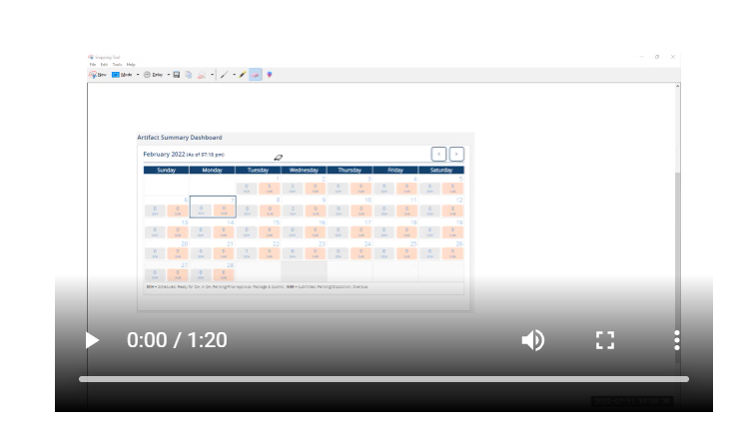

To add the demo portion to your site, copy the code below:

<video width="320" height="240" class="center" controls>

              <source src="../Images/USI-KT Recordings Day2.mp4" type="video/mp4" class="center">

              Your browser does not support the video tag.

            </video>

(5) In the demo section, there will be a source src tag, in this tag you will write the name of the file of the mp4 file in which you conducted the demo. After taking a snapshot of your video, make sure to go in and save it with a unique title that you will remember in the images folder.

* 1. Editing email signage



To add the email signage portion to your site, copy this code below:

<div class="mt-5 bg-dark text-white text-center" >

    <p>Powered By Deloitte</p>

    <p>Please contact us for any further inquiries: <a href="mailto:megrajesh@deloitte.com?subject=SOP Inquiry:Dashboard&body=Dear Megha,">Send Email</a> </p>

</div>

(1) The <a href:mailto:megrajesh@deloitte.com> portion will prompt the site to open up an email to the party [megrajesh@deloitte.com](mailto:megrajesh@deloitte.com)

(2)The ?subject=SOP Inquiry:Dashboard portion will add a subject line of SOP Inquiry:Dashboard to the email

(3) The &body=Dear Megha, portion will begin the body of the message with Dear Megha,

(4) The send email portion beyond the tag will be the verbiage that will be used on the SOP site that users have to click in order to redirect to a direct mail.